The log shows this burst failed at 03:00:07 AM
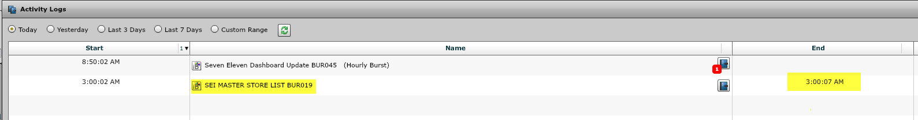
This burst is part of the S-M-T-W-T-F-S@6AM schedule.
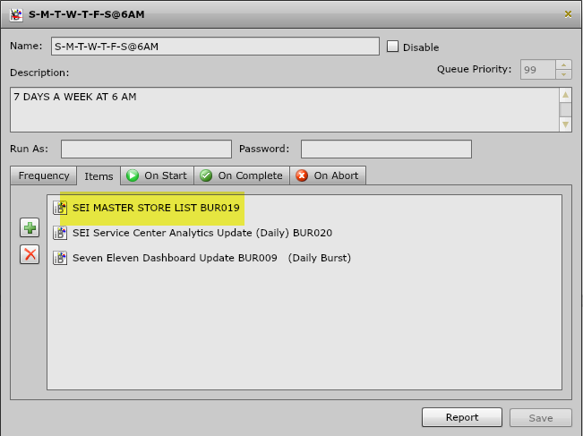
Here the start time is shown for this schedule.
